Model Development Phase

Date | 7 February 2026
Team ID | LTVIP2026TMIDS52507
Project Title | IntelliSQL: Intelligent SQL Querying with  LLMs Using Gemini Pro
Maximum Marks | 4 Marks

Initial Model Training Code, Model Validation and Evaluation Report
In the IntelliSQL project, a pre-trained large language model (Google Gemini Pro) is used to generate SQL queries from natural language inputs. Since the model is already trained on largescale code and text data, no custom model training is performed. The implementation focuses on model initialization, prompt engineering, input validation, and evaluating query generation performance during real-time inference.
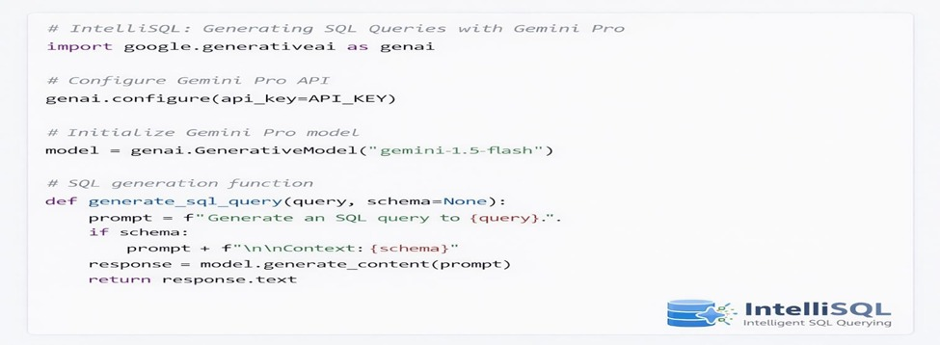
Model Validation and Evaluation Report:
Since IntelliSQL is an inference-based system, evaluation is performed using qualitative and functional validation metrics rather than traditional accuracy-based metrics.

Evaluation Criteria
Metric | Description
Translation Accuracy | Assessed by comparing generated SQL with expected correct SQL queries
Context Preservation | Evaluates whether user intent and constraints are correctly reflected in  SQL
Response Time | Measures time taken to generate SQL query
Query Coverage | Verifies correct handling of different SQL operations
Error Handling | Validates system behavior for empty, ambiguous, or invalid input

Model Evaluation Summary

Evaluation Aspect | Result
SQL Generation Quality | High
Context Awareness | High
Response Time | Low latency
Query Coverage | Successful
Overall Performance | Satisfactory

Validation Approach

Validation Method | Description
Manual Validation | Sample natural language queries are manually converted into SQL and compared with system-generated SQL to verify correctness and intent matching.
Query Length Testing | The system is tested using short, medium, and complex queries to evaluate consistency and performance across varying query lengths.
Query Type Testing | Multiple query types (SELECT, JOIN, WHERE, GROUP BY, etc.) are tested to ensure reliable SQL generation and correct query construction.
UI-Level Validation | Input validation is performed at the user interface level to handle empty queries, missing schema details, and invalid inputs gracefully.

